**JENKINS SMTP email Service configuration**

Follows the Video link for Jenkins Installation

[session 2 | Jenkins installation on ec2 instance, concepts | integration GitHub, First Pipeline (youtube.com)](https://www.youtube.com/watch?v=_x8wxDBPfHs)

**GITHUB – WEBHOOKS – JENKINS – DEPLOYMENTSERVER –**

**Pipeline failed – need Alert**

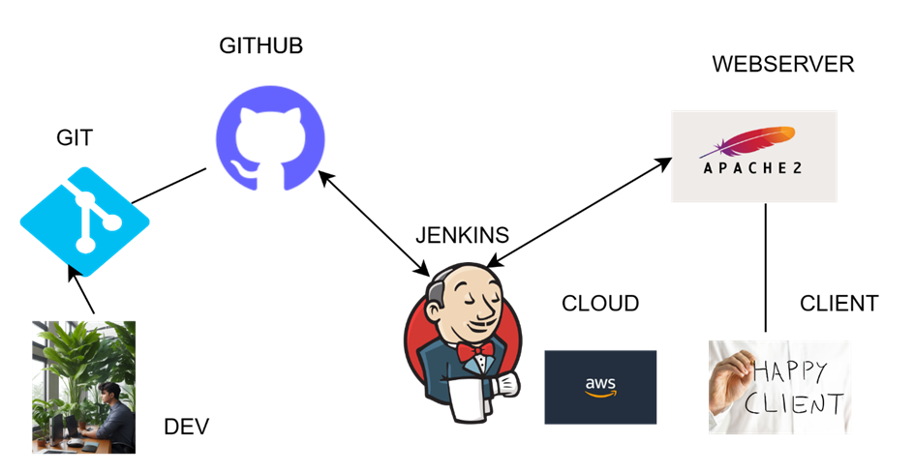

access through url : <https://dev.cloudaseem.com>

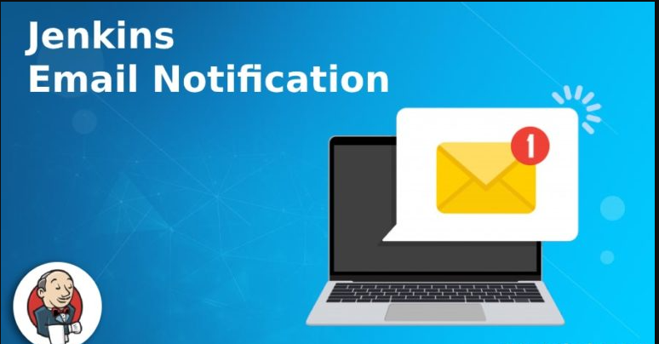

In Jenkins, a popular open-source automation server, set up email notifications in a Jenkins pipeline using Gmail as the email provider, you can use the email text plugin. Here's a basic example of how you can configure email notifications in a Jenkins pipeline script:

Install Plugins:

Make sure that the " Mailer Plugin " is installed in your Jenkins instance. You can install it from the Jenkins dashboard under "Manage Jenkins" -> "Manage Plugins" -> "Available" tab.

Configure SMTP Server:

Go to "Manage Jenkins" -> "Configure System" and scroll down to the "E-mail Notification" section. Set up the SMTP server details for Gmail. Here are the typical settings:

Go to Pipeline in which you want to configure email notification to received on Pipeline Build fails.

Go to "Manage Jenkins" -> "Configure System" and scroll down to the "E-mail Notification" section. Set up the SMTP server details for Gmail

Go to Jenkins:

Smtp – smtp.gmail.com

Default - @gmail.com

Use SMTP authentication

User - [xyz@gmail.com](mailto:xyz@gmail.com) # use your email address

Password – ******* use your credentials

Port 587

Reply to address   
add email notification to be send to

Let’s create a pipeline for testing

*** Post-build Actions select email notification

Apply Jenkins permission to directory

sudo chown -R jenkins:jenkins /var/www/html

Pipeline Script:

Make sure to replace 'recipient@example.com' with the actual email address where you want to receive notifications and replace 'your.email@gmail.com' with your Gmail email address.

Note: For security reasons, it's recommended to use Jenkins Credentials for sensitive information such as email username and password. You can configure Jenkins credentials in the "Manage Jenkins" -> "Manage Credentials" section and then use those credentials in your pipeline script.